SELF-RESPONSIBILITY and
THE POLARITY OF INSTITUTIONS AND ASSOCIATIONS
Magdalena Valderrama, November 7, 2014

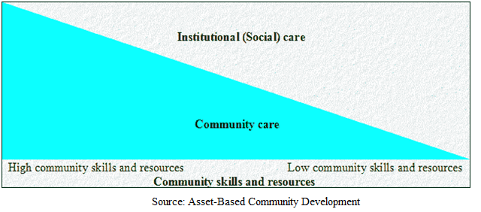
Figure 1 - A fundamental dilemma over care provided by institutions and care provided within a community.
When the community holds all the skills, organization tends to be haphazard and institutions tend to be weak or non-existent. When institutions hold all the skills, communities and individuals tend to be weak and dependent.

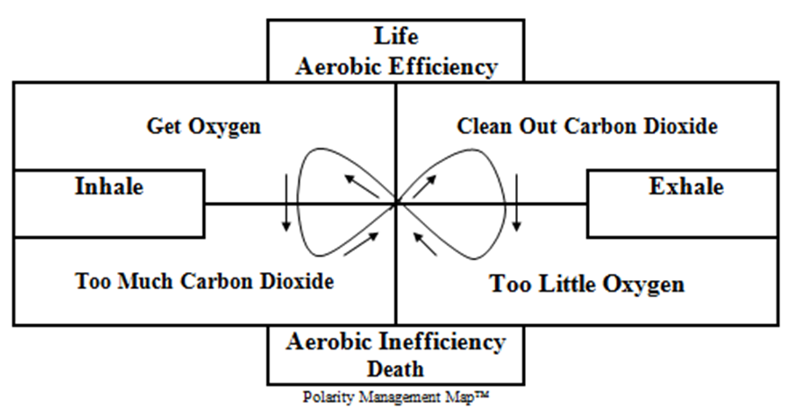
Figure 2 - The fundamental dilemma and polarity inherent in breathing

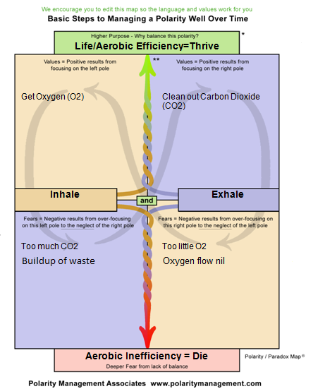
Figure 3 - Comparison of the values and purposes and the fears and negative results at play in the polarity of breathing
Figure 2 shows the basic polarity of breathing. Figure 3 shows the same polarity detailing the responses that arise in people experiencing the polarity. When people focus exclusively on one pole, the fears and negative outcomes that result correspond to the purpose and value of the opposing pole.
Compare the polarity of institutions and associations (community groups) to the fundamental polarity of breathing. A thriving society needs both its institutions and its community groups and individuals to be functioning , just as life-supportive breathing is made up of both processes of inhalation and exhalation. When a society relies solely on Institutions for purposes and values uncharacteristic of them such as caring for individuals or seeing to their individual circumstances, or when a society ignores its responsibility for an institution, the situations being addressed quickly become problems for damage control. When a society relies solely on community groups and individual members for uncharacteristic purposes and values such as addressing long-term needs or speedy and copious production, the situations being addressed quickly become problems of unreliability and even rebellion. Either way, the once-important values and purposes embodied in either approach become instead habits of self-righteousness and finger-pointing.

Figure 4 - How Institutions and Community Groups see themselves embodying principal values

Figure 5 - How Institutions and Community Groups see each other embodying the worst traits
The way beyond the polarity is to embrace both processes and assume collective self-responsibility and address the whole, as a prior unity. Collectively managing such a polarity is to move away from trying to solve a problem that doesn't exist. Action steps can more easily be identified and applied at various positions of time as we recognize the key values and purposes at play, and know where we are within the cycle of values and fears and between the poles of apparent opposites.
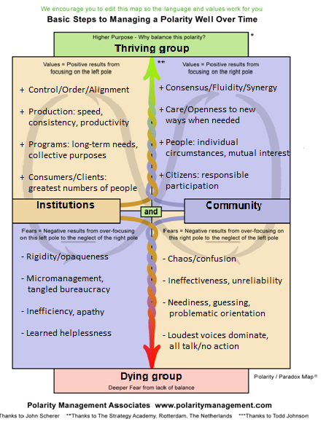
Figure 6 - Analysis of the values and fears at play in the polarity of group relationships
As in the fundamental polarity of our breath, Figure 6 details the responses that arise in people experiencing the polarity of institutional activity and community activity. When people focus exclusively on one pole, the fears and negative outcomes that result correspond to the purpose and value of the opposing pole.

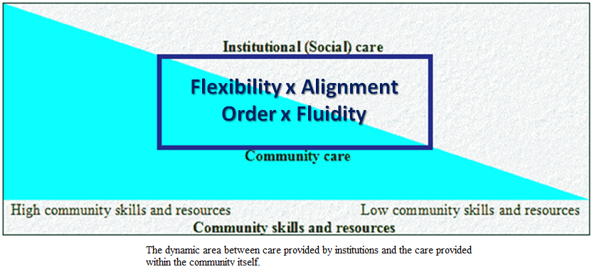
Figure 7 - The dynamic and ongoing play between the values of order and fluidity, flexibility and alignment
Focusing on any single corner of the graph represents exclusive reliance on either pole of institutional and community care. There may be times when the values and purposes represented by institutions or communities are inevitable or necessary, as in times of calamity. It is only when the collective society drops its responsibilities for the "other side" that habits get stuck. A thriving group is able to manage itself in dynamic equilibrium.
There are many methodologies available in the world that can be used to help people recognize these types of sources of conflict and organizational dysfunction. Both the methodologies of Asset-Based Community Development and Polarity Management include ways to assess where a group is in the cycle and action steps to help keep the group growing and moving forward.

Community skills diagram from presentation on Asset-BAsed Community Development given by Ron Dyer-Voss at the Pacific Lutheran School of Theology, Berkeley, CA, January 2012. Overlays added.
Barry Johnson, Ph.D. et al quoted in http://lipscombicm.wordpress.com/2010/10/01/polarity-management-the-creative-power-of-the-conceptual-age/
A blank template of this chart was once available at http://www.polaritypartnerships.com/what-we-do The original template is ingenious in that it allows the user to tab through each area of the chart in the same order and flow that it takes to analyze and understand the relationships between one's fears and negative results with the other's values and purposes. Figure 6 was developed using this template.
There are many other polarities that have already been analyzed and put to use in organization development and peace-keeping efforts, such as between structured and adaptive leadership, directive and participative decision-making, relationships and productivity, frankness and diplomacy, just to name a few. See the materials contained in the references mentioned in Endnote 3.

